Name :- Purushottam Kumar

ID :- 2041

MCA I-Sem (R)

Submission Date :- 06-Mar-2021

**Python Lab session 9 (05-03-2021)**

**Assignment**

1. Write a program that finds the greatest of three given numbers using

**( Program – 1 )**

functions. Pass the numbers as arguments.

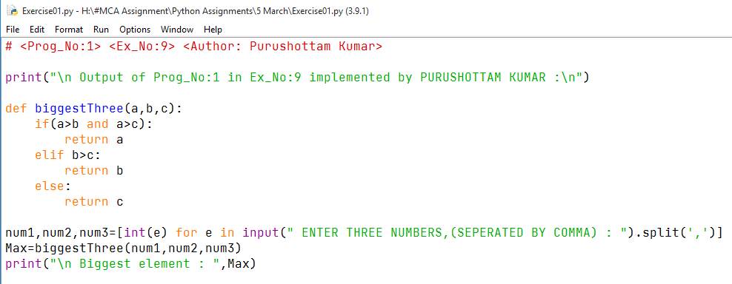

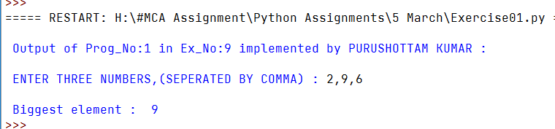 **OUTPUT**

2.Write two functions simple_interest() and compound_interest() that returns the simple and compound interest if relevant arguments are passed to the functions.

**( Program – 2 )**

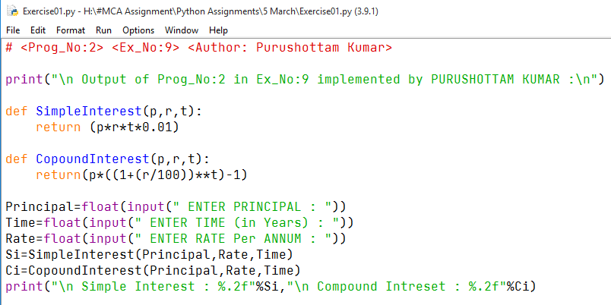

**OUTPUT**

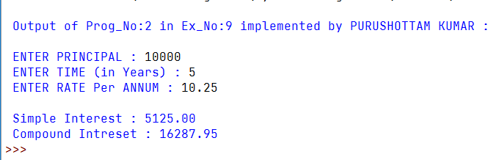

1. Write a function accepts an integer between 1 and 12 to represent the month number and displays the corresponding month of the year (For example, if month = 1, then display JANUARY). If the function receives any value which is not in the range 1 to 12 display error message and prompt for correct input.

**( Program – 3 )**

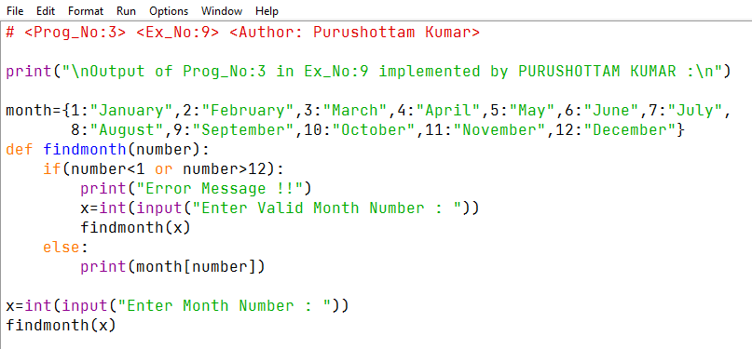

**OUTPUT**

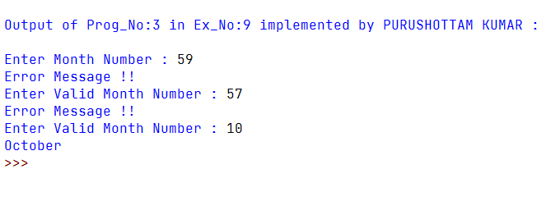

1. Write a program to calculate the factorial of a given number using function and recursion.

**( Program – 4 )**

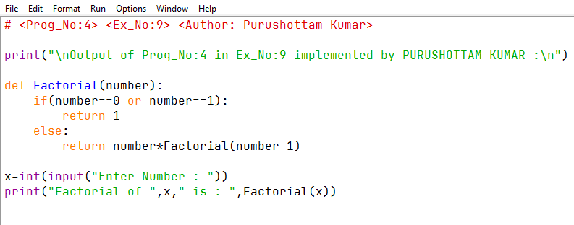

**OUTPUT**

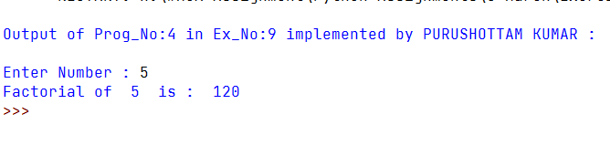

1. Write a program to generate the Fibonacci series of a given numbers using function and recursion.

**( Program – 5 )**

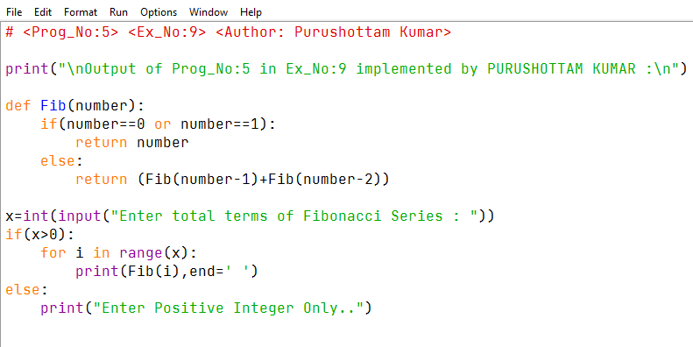



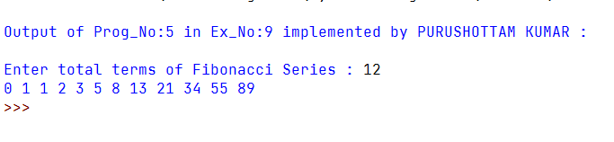

1. Write a function that receives a number and checks whether it is a palindrome or not.

**( Program – 6 )**

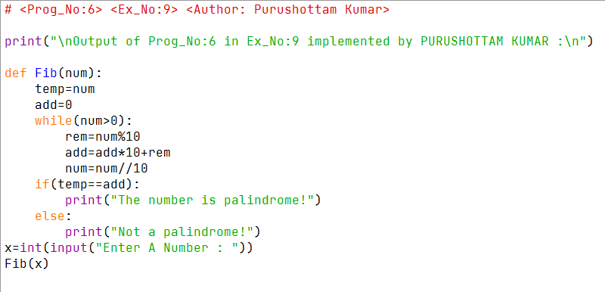



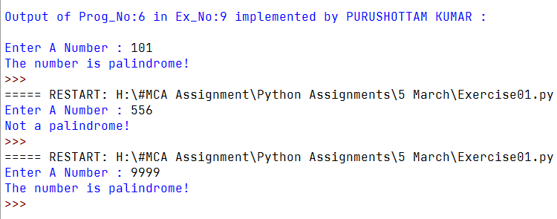

1. Write a function that receives a number and checks whether it is an Armstrong number or not.

**( Program – 7 )**

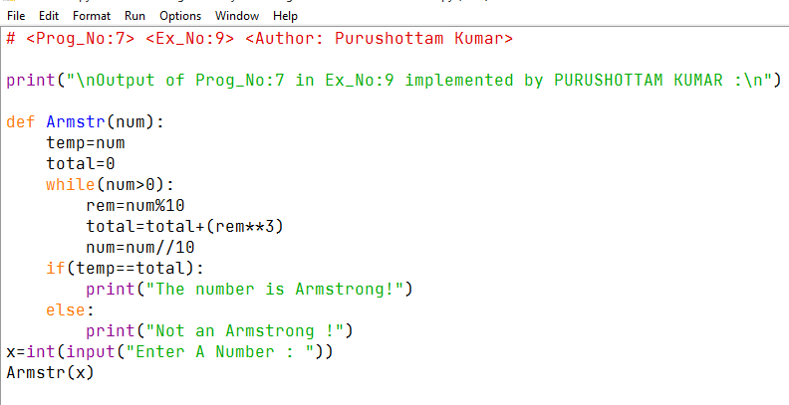

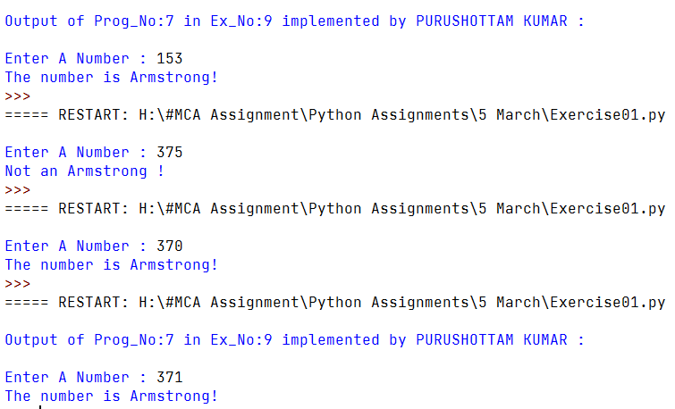

1. Write a function that accepts 5 integers, and returns TRUE if they are sorted, otherwise it returns false and prompts the user WHETHER TO SORT THE NUMBERS OR NOT. If the user enters YES, then another function must sort the 5 numbers and return the sorted series.

**( Program – 8 )**

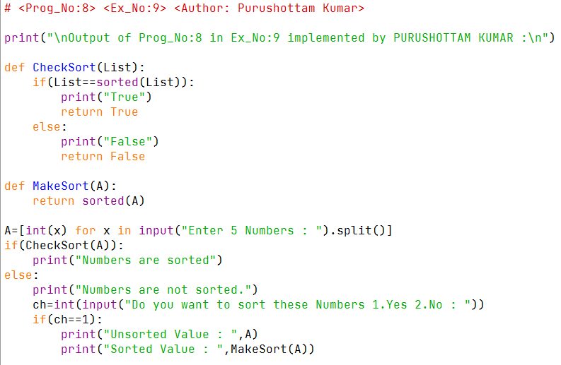

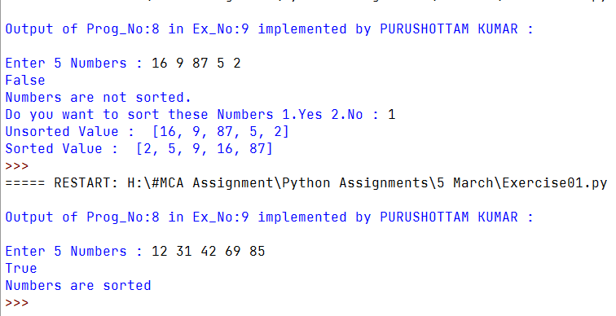**OUTPUT**

1. Write a program to reverse a string using function and recursion.

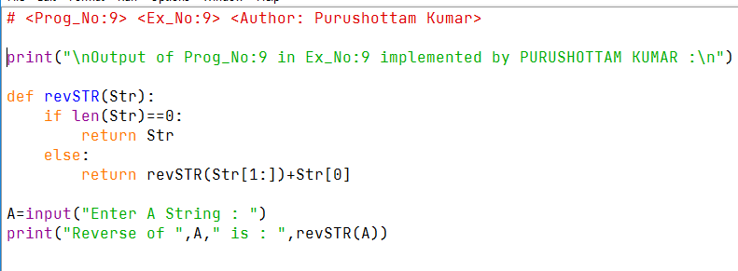

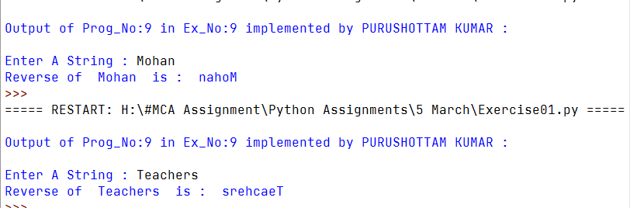

1. Write a menu driven program using functions to perform basic arithmetic operations such as addition, subtraction, multiplication, division, modulo, to the power of, log and square root.

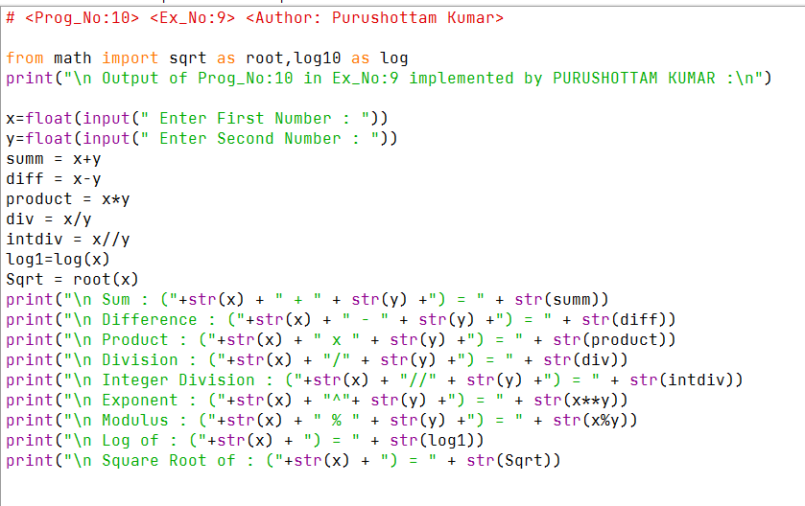

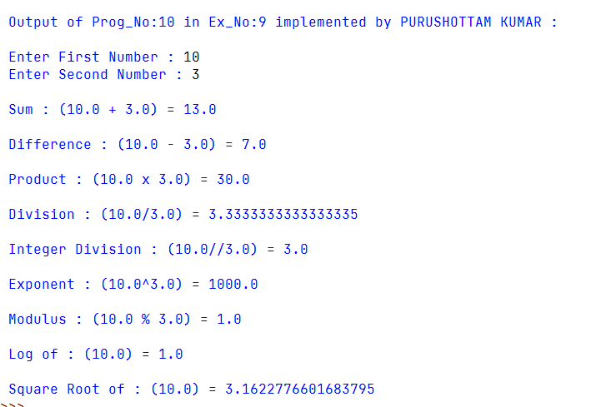**OUTPUT**